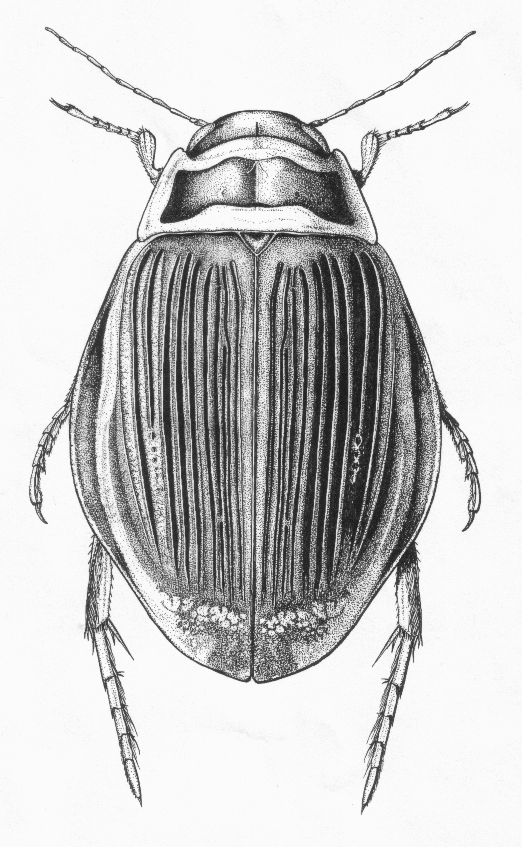 | Balfour~Browne Club Meeting 2005: Sigulda, Latvia | 
in co-operation with the Entomological Society of Latvia

Date / Time 10-12 June, 2005.
Place Sigulda, Gaujas National Park, Latvia/Lettland/Lettonie
Map (Latvia): http://www.uzkartes.lv/?&lang=2&lchange=1
Map (Gaujas NP): www.gnp.gov.lv/eng/mes_esam.htm
The town of Sigulda, also called the “Livonian Switzerland”, is 45 km E of Rīga, the capital of Latvia, in the Gaujas National Park, one of the most beautiful and diverse places in the Baltic region.

Provisional programme
Friday 10 June – arrivals, registration, short excursions, welcome party;
Saturday 11 June – field trip to the Gaujas NP; evening plenary session; beer (with an optional visit into town);
Sunday 12 June – field trip to Lake Kanieris (Ķemeru NP); evening plenary session; beer (with an optional visit into town);
Monday 13 June – (optional) excursion to the Rīga Zoo insectarium; departures.

Costs and accommodation
Meeting fee: € 35/GBP 25.
payable by cash on arrival/registration – or by money transfer (contact the Organisation Committee for account details).
Excursions: Gaujas NP + Ķemeru NP (together) - € 45 /GBP 35.
Rīga Zoo insectarium: € 5/GBP 3.
Excursions are payable by cash on arrival / registration. These prices might change depending on changes in exchange rates.

 | Hotel “Sigulda”, Pils iela 6, LV-2150 Sigulda, Latvia/ Lettland/Lettonie  Hotel’s web page: www.hotelsigulda.lv  Booking:  Phone/fax (+371) 7972263, (+371) 7971443  E-mail: hotelsigulda@latnet.lv

 | Price (in LVL) *
Rooms
Single | 30.-
Double | 42.-
Food**
Lunch | from 5.-
Dinner | from 5.-
Banquet | from 8.-
* 1 Latvian Lats (LVL) = € 1.5 = GBP1.
** depending on your wishes

Additional possibilities (at the hotel):
- wireless internet € 2/ hour
- relaxation & fitness centre (sauna, basin, massage etc.)
- musical evenings, karaoke
- excursions (non-entomological!)
- bowling
- river rafts
- bobsleigh: downhill journey by “Vučko” cart

Field trips
- Excursion to the Gaujas National Park. – an area with high fresh water diversity (well springs, streams, rivers of different types and sizes, lakes, ponds, mires, peat bogs, old river-beds etc.). Also with important historical and architectural monuments (Cēsis, the old capital of Livonia; the Turaida castle etc.). In total, 1,584 beetle species are known from the Gaujas NP (~40% of known Latvian fauna). Of these 165 are aquatic beetle species (incl. rich populations of Dytiscus latissimus, Graphoderus bilineatus and Deronectes latus). A full species list is available (on request) from Dmitry Telnov (telnov@parks.lv). Gaujas NP: www.gnp.gov.lv
- Excursion to the lake Kanieris (Ķemeru NP) – a typical large natural lagunal-type lake, also with numerous other water types like peat bogs, sulphur well springs, slow-moving rivers, etc.). Also typical Latvian coastal fishery villages, with freshly smoked fish and the Rīga Gulf coast (not the wildest place, sorry). Ķemeru NP: www.kemeri.gov.lv
- Rīga Zoo insectarium – voted Europe’s best invertebrate exposition 2003/2004 (but no aquatic Coleoptera in the exhibition!). Rīga Zoo: www.rigazoo.lv

How to come to Latvia
By air: www.riga-airport.com recommended (cheapest) flights by www.airbaltic.lv, www.ryanair.com, www.easyjet.com
By ferry: www.rigasealine.lv/en/index.asp
By train: www.ldz.lv/en/index.html
By bus: www.eurolines.lv, www.ecolines.lv, www.autoosta.lv/en/index_en.htm (bus connections inside Latvia)
By car: use standard European road maps (follow E67 “Via Baltica” main road from Berlin to Helsinki via Rīga). Latvian roads: www.lad.lv/en/default.asp?i=1
Useful link to the public transport & taxi in the Rīga city, also for connections to Rīga from around the World: www.rigatourism.com
Route from Rīga to Sigulda: information will be given to all registered participants in Spring 2005.

Contacts / Organisation comittee
The Entomological Society of Latvia, 4 Kronvalda Blvd., LV-1586 Rīga, Latvia/ Lettland/Lettonie
Dmitry Telnov - telnov@parks.lv phone (+371) 6356968
Mārtiņš Kalniņš - E-mail: martins.malnins@dap.gov.lv phone (+371) 6457974

Registration form
See separate page

