Latvijas entomologs
Supplementum VI

Proceedings
of the 3rd Symposium and Workshop
on the Conservation of Saproxylic Beetles

Rīga / Latvia, 07th – 11th July, 2004

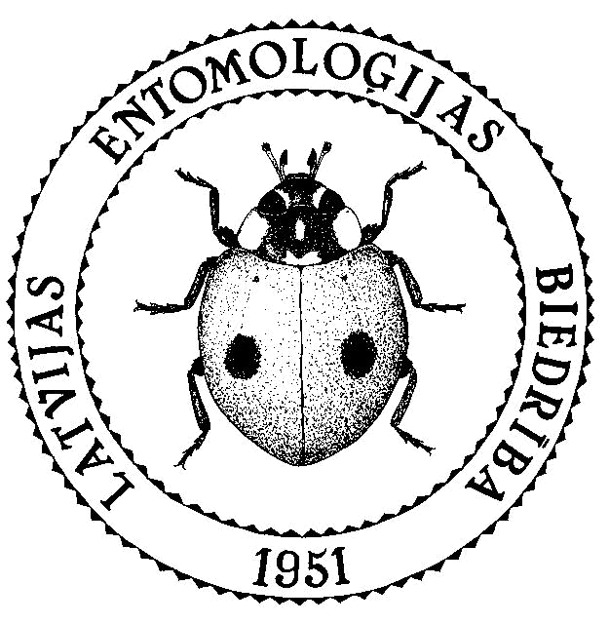

Rīga, 2005

Proceedings of the 3rd Symposium and Workshop
on the Conservation of Saproxylic Beetles

Latvijas entomologs, Supplementum VI

Izdevējs © Latvijas Entomoloģijas biedrība. Reģistrācijas apliecība Nr. 1579

Datorsalikums: D.Telnov. Nodots iespiešanai 2005.g. 10. maijā
Iespiests: SIA “Petrovskis & Ko”, Noliktavas ielā 3, LV-1010 Rīga, Latvija
Latvijas entomologs: ISSN 9984-9768-0-7

This publication and its individual papers should be cited as follows:

Telnov D., 2005. Ceruchus chrysomelinus (Hochenwarth, 1785) (Lucanidae) in Latvia: Distribution and Ecology: 93-96. In: Barclay M.V.L., Telnov D. (eds.). Proceedings of the 3rd Symposium and Workshop on the Conservation of Saproxylic Beetles, Rīga / Latvia, 07th-11th July, 2004. – Latvijas entomologs, Supplementum VI.

Contact Details of Editors:

Maxwell V.L. Barclay
Department of Entomology
The Natural History Museum
SW7 5BD London, United Kingdom
Phone: (+44) (0) 207 942 5911
E-mail: m.barclay@nhm.ac.uk

Dmitry Telnov
The Entomological Society of Latvia
c/o: Faculty of Biology
4 Kronvalda Blvd., LV-1586 Rīga, Latvia
Phone: (+371) 6356968
E-mail: telnov@parks.lv
Table of Contents

Keith N.A. Alexander  The Development of an Index of Ecological Continuity for Site Quality Assessment for Saproxylic Coleoptera ……………………………………………………………………. | 5
Christophe Bouget, Frédéric Gosselin  Windthrow Gaps as Dead Wood Islands for Saproxylic Beetles in Managed Deciduous French Forests ……………………………………………………………………………. | 16
Hervé Brustel  Biological Value of French Forests Assessed with Saproxylic Beetles: a Way to Conserve this Natural Heritage …………………………………………………………... | 26
Niklas Franc  Saproxylic Beetles on Snags and Logs of Oak (abstract) …………………………........... | 50
Colin J. Hawes  The Stag Beetle Lucanus cervus (L.) (Coleoptera: Lucanidae) in the County of Suffolk (England): Distribution and Monitoring …………………………………………………. | 51
Alexander G. Kirejtshuk  Diversity of “Saproxylic” Beetles in the Past, as Represented in the Catalogue of the World Fossil Coleoptera at www.zin.ru/animalia/coleoptera/eng/paleosys.htm ................ | 68
Thomas Ranius  Osmoderma eremita (Scopoli, 1763) (Coleoptera: Scarabaeidae: Cetoniinae) in Europe: a Short Summary of a Pan-European Project ……………………………………………. | 79
Dmitry S. Schigel  Polyporus pseudobetulinus (Pilát) Thorn, Kotir. & Niemelä – Rare Polypore Fungus (Basidiomycetes, Aphyllophorales) in Finland, and its Beetles ………………………….. | 83
Jiří Schlaghamerský  Saproxylic Beetles of a Hardwood Floodplain Forest Canopy …………………………... | 85
Dmitry Telnov  Ceruchus chrysomelinus (Hochenwarth, 1785) (Lucanidae) in Latvia: Distribution and Ecology ………………………………………………………………………………. | 93
Veerle Versteirt, Philippe Fayt, Pierre Hastir, Jean-Marc Henin, Jonathan Lhoir, Marc Dufrêne  The Belgian (Saproxylic) Elateroidea Fauna in Danger ? A Study in Decidous Forests in Southern Belgium ………………………………………………………………………… | 97
Vincent Vignon, Jean-François Asmodé, Philippe Rapaport  Heterogeneity of the Spatial Distribution of Osmoderma eremita (Scopoli, 1763) Populations in a Hedgerows Network (France, Normandy) ……………………………... | 109
Paul F. Whitehead  Baseline Data for the Coleoptera of Mt Ainos National Park, Kefallinia, Greece ………. | 116
Imogen Wilde  The Shadier Side of Epping Forest: Saproxylic Coleoptera Research …………………… | 124

List of Registered Participants

Name, Surname | Country | E-mail
Keith Alexander | United Kingdom | keith.alexander@waitrose.com
Christophe Bouget | France | christophe.bouget@nogent.cemagref.fr
Clare Bowen | United Kingdom | clare@ptes.org
Hervé Brustel | France | brustel@esa-purpan.fr
Karel Chobot | Czech Republic | karel_chobot@nature.cz
Adrian Fowles | United Kingdom | a.fowles@btinternet.com
Niklas Franc | Sweden | niklas.franc@zool.gu.se
Jānis Gailis | Latvia | ectobius@hotmail.com
Colin J. Hawes | United Kingdom | colinjhawes@btopenworld.com
Valerie Keeble | United Kingdom | valerie@ptes.org
Alexander G. Kirejtshuk | Russia | ak3929@ak3929.spb.edu
Polina A. Kirejtshuk | Russia
Brian Levey | United Kingdom | brian.levey@nmgw.ac.uk
Georg-Christian Möller | Germany | georg-christian.moeller@t-online.de
Doug Napier | United Kingdom | doug.napier@cip.org.uk
Thierry Noblecourt | France | thierry.noblecourt@onf.fr
Uģis Piterāns | Latvia | cerambyx@inbox.lv
Thomas Ranius | Sweden | thomas.ranius@entom.slu.se
Dmitry S. Schigel | Finland | dmitry.shchigel@helsinki.fi
Jiří Schlaghamerský | Czech Republic | jiris@sci.muni.cz
Matthew Smith | United Kingdom | matsmith1@compuserve.com
Dmitry Telnov | Latvia | telnovs@finieris.lv
Veerle Versteirt | Belgium | veerle.versteirt@naturalsciences.be
Vincent Vignon | France | v.vignon@oge.fr
Jonathan Webb | United Kingdom | jon.webb@english-nature.org.uk
Imogen Wilde | United Kingdom | imogen.wilde@corpoflondon.gov.uk
Paul F. Whitehead | United Kingdom | paul@moorleys.freeserve.co.uk
Neculiseanu Zaharia | Moldova | zneculiseanu@yahoo.com

